**COMPETITIVE ANALYSIS OF LEADING**

**TRAVEL AGGREGATORS**

**A PROJECT REPORT**

***Submitted by***

|  |  |
| --- | --- |
| **TEAM ID** | **NM2023TMID04865** |
| SHAHRUKH FAKRUDEEN K | 311820106021 |
| AHMAD SYED SEMAR | 311820106004 |
| KISHORE S | 311820106011 |
| AMUDESHWARAN S  (Team Leader) | 311820106005 |

***In partial fulfillment of the award of the***

***degree of***

BACHELOR OF ENGINEERING

**NAAN MUDHALVAN**

**DATA ANALYTICS (IBM)**

**MOHAMED SATHAK A J COLLEGE OF**

**ENGINEERING**

**2020 – 2024**

### BONAFIDE CERTIFICATE

Certified that this project report **“COMPETITIVE ANALYSIS OF LEADING TRAVEL AGGREGATORS”** is the Bonafide work of the following students, **SHAHRUKH FAKRUDEEN K (311820106021), AHMAD SYED SEMAR (311820106004), KISHORE S (311820106011), AMUDESHWARAN S (311820106004)** in partial fulfilment for the award of the **NAAN MUDHALVAN** and the project work is carried out under my supervision.

### ACKNOWLEDGEMENT

This satisfaction and successful completion of any task could be incomplete without mentioning the people who made it possible, whose constant guidance and encouragement crown our efforts with success.

We express our sincere and deep gratitude to our beloved assistant professors and technicians for their kind cooperation, moral support, and encouragement in completing this work. We express our thanks to all those who helped us directly or indirectly in the successful completion of this project work.

### TABLE OF CONTENTS

#### INTRODUCTION

* 1. Project Overview

#### Purpose

1. IDEATION AND PROPOSED SOLUTION

#### Problem Statement Definition

* 1. Ideation & Brainstorming

#### Empathy Map Canvas

* 1. Problem Solution

1. REQUIREMENT ANALYSIS

#### Functional requirement

* 1. Non-Functional requirements

1. PROJECT DESIGN

#### Data Flow Diagrams

* 1. User Stories

#### Solution &Technical Architecture

1. CODING & SOLUTIONING

#### RESULTS

* 1. Performance Metrics

#### ADVANTAGES AND DISADVANDVANTAGES

1. FUTURE SCOPE
2. CONCLUSION

**ABSTRACT**

This research project focuses on the problem of the overwhelming number of travel aggregators in the market and the challenges faced by users in selecting the most suitable platform for their travel needs. In response to this problem, GlobalTap, a comprehensive travel analysis platform, has been developed to provide detailed information and analysis of leading aggregators. The objective is to conduct a comprehensive competitive analysis of the top aggregators, evaluating their features, functionality, and user experience. GlobalTap aims to empower users with valuable insights to make informed decisions and enhance their travel experiences.

GlobalTap serves as a resource for travelers, equipping them with detailed information and analysis of leading aggregators. By addressing the problem statement of the overwhelming number of aggregators and the need for informed decision-making, GlobalTap streamlines the process of choosing a travel aggregator. Through its in-depth analysis, GlobalTap enables users to navigate the aggregator landscape more effectively and select the most suitable platform based on their preferences and requirements. It empowers users with the knowledge to optimize their travel plans and have a more satisfying and enjoyable travel journey.

By incorporating user feedback and integrating advanced analytics, GlobalTap continuously evolves to deliver personalized recommendations and enhance the overall travel experience for users. The project contributes to the travel industry by providing a focused analysis of leading aggregators, highlighting areas of improvement and innovation in the competitive market. GlobalTap's comprehensive analysis and user-centric approach bring a unique value proposition to the travel aggregator landscape, helping users make better-informed decisions and boosting their overall travel experience.

**1. INTRODUCTION**

**1.1 Project Overview:**

In today's fast-paced world, travelers face the daunting task of navigating through a myriad of travel aggregator options, often resulting in confusion and uncertainty. The lack of a centralized platform for accessing reliable and consolidated information further exacerbates the challenge. Recognizing the need for a comprehensive solution, our project aims to revolutionize the way travelers make informed decisions by providing them with a sophisticated data analysis and visualization platform. Through cutting-edge technologies and data-driven methodologies, our solution empowers users with valuable insights, comparisons, and comprehensive evaluations of leading travel aggregators. By leveraging advanced algorithms and machine learning models, we can analyze vast amounts of data and present it in a user-friendly interface, enabling travelers to easily compare pricing, availability, user reviews, and other key factors.

Our goal is to simplify the decision-making process, ultimately enhancing the overall travel experience for individuals worldwide. By offering a centralized hub of information and tools, our project aims to alleviate information overload and provide travelers with the confidence to choose the most suitable travel aggregator for their specific needs. Through an intuitive and user-friendly interface, users can access comprehensive data, explore interactive visualizations, and gain a deeper understanding of the strengths and weaknesses of different travel aggregators. With our project, we seek to empower travelers, saving them time and effort while ensuring they make well-informed decisions that enhance their travel experiences.

**1.2 Purpose:**

The purpose of this project is to address the challenge of limited access to reliable and consolidated information about leading travel aggregators. The problem statement, 'Competitive Analysis of Leading Travel Aggregators,' revolves around the difficulty faced by travelers in making informed decisions due to the lack of a centralized platform for comparing and analyzing different travel aggregators. Our solution aims to provide users with a user-friendly web application that consolidates data from multiple sources, allowing them to access comprehensive information, ratings, reviews, and insights about various travel aggregators. By offering a platform that facilitates data-driven decision-making, our project seeks to empower travelers and enhance their overall experience in selecting the most suitable travel aggregator for their needs.

**2. IDEATION & PROPOSED SOLUTIONS**

**2.1 Problem Statement Definition:**

The problem statement for our project, "Competitive Analysis of Leading Travel Aggregators," revolves around the challenge faced by travelers in obtaining reliable and consolidated information about different travel aggregators. The abundance of options and the lack of a centralized platform make it difficult for users to compare and analyze various travel aggregators effectively. This leads to decision-making challenges and hampers the ability to make informed choices.



**2.2 Ideation & Brainstorming:**

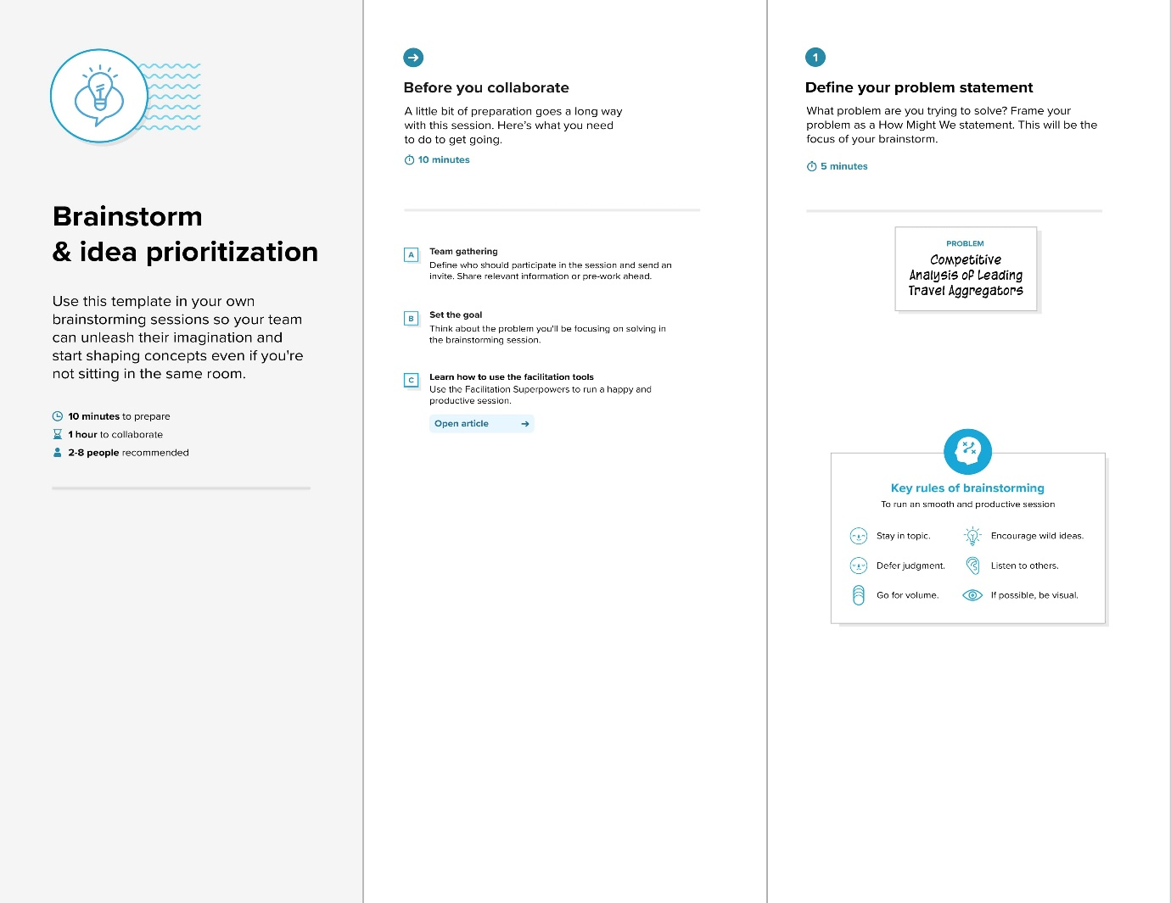During the ideation and brainstorming phase, we explored various ideas and concepts to address the identified problem statement. We engaged in creative thinking and collaborative discussions to generate innovative solutions. Our team brainstormed potential features, functionalities, and approaches that would provide users with a comprehensive and user-friendly platform for comparing and analyzing different travel aggregators.

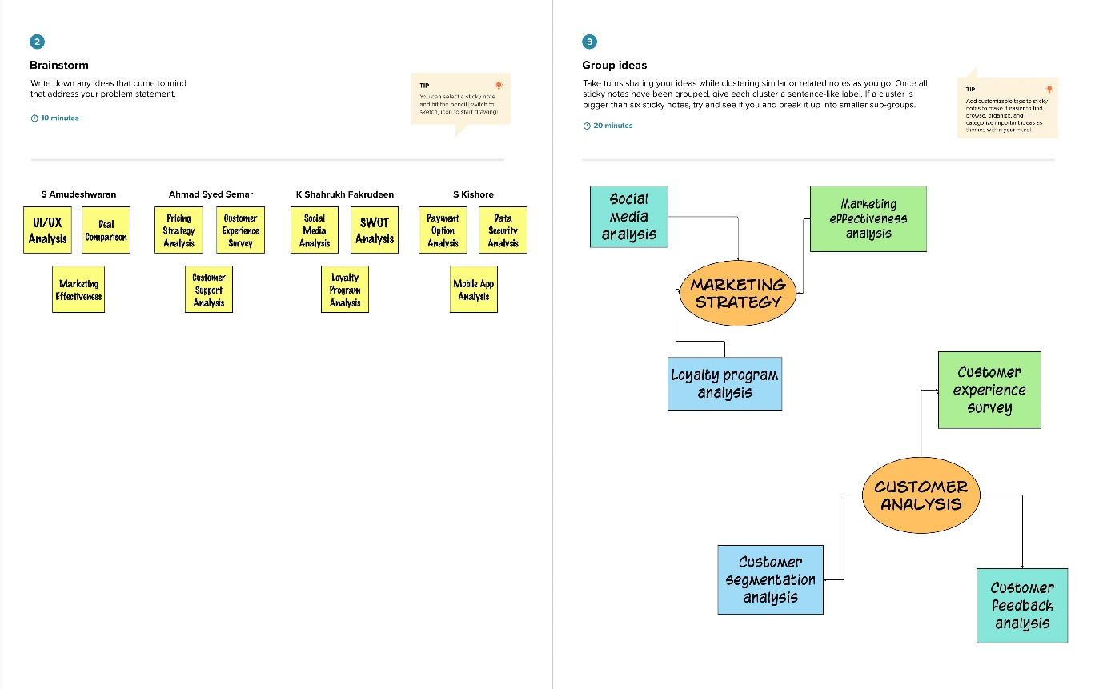

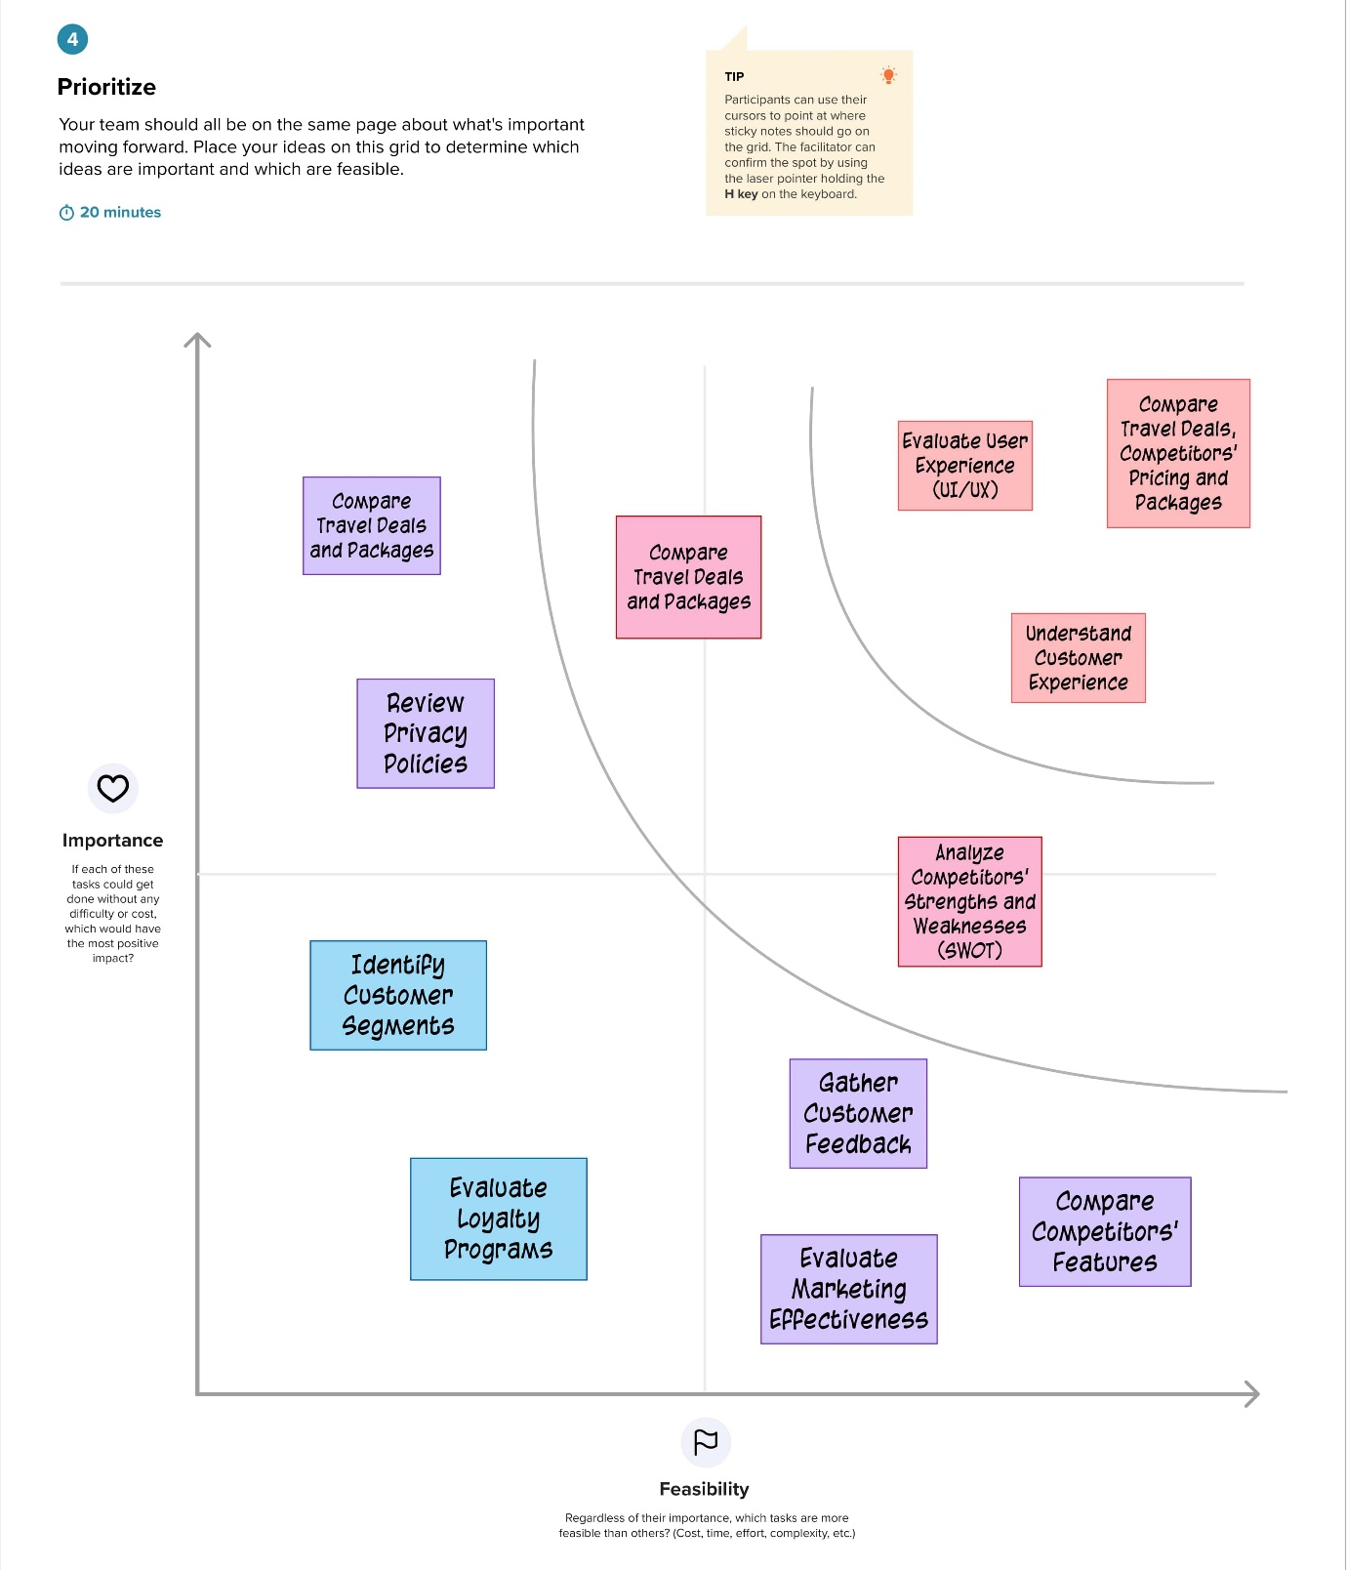

**2.3 Empathy Map Canvas:**

To gain a deeper understanding of the users' needs and pain points, we conducted an empathy map exercise. This involved putting ourselves in the shoes of travelers and considering their thoughts, feelings, needs, and aspirations when interacting with travel aggregators. The empathy map helped us uncover valuable insights and empathize with the users' experiences, allowing us to design a solution that caters to their specific requirements.

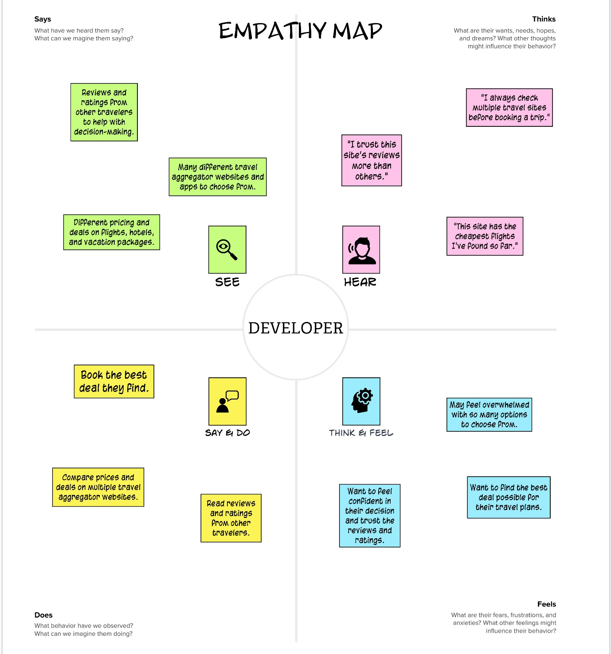

**2.4 Proposed Solution:**

After careful consideration and evaluation, we arrived at the proposed solution for our project. Our solution involves developing a robust web application that aggregates data from multiple sources and presents it in an intuitive and visually appealing manner. Users will have access to comprehensive information, ratings, reviews, and insights about leading travel aggregators, enabling them to make informed decisions. The proposed solution aims to streamline the process of comparing travel aggregators, empower users with data-driven decision-making capabilities, and enhance their overall travel booking experience.

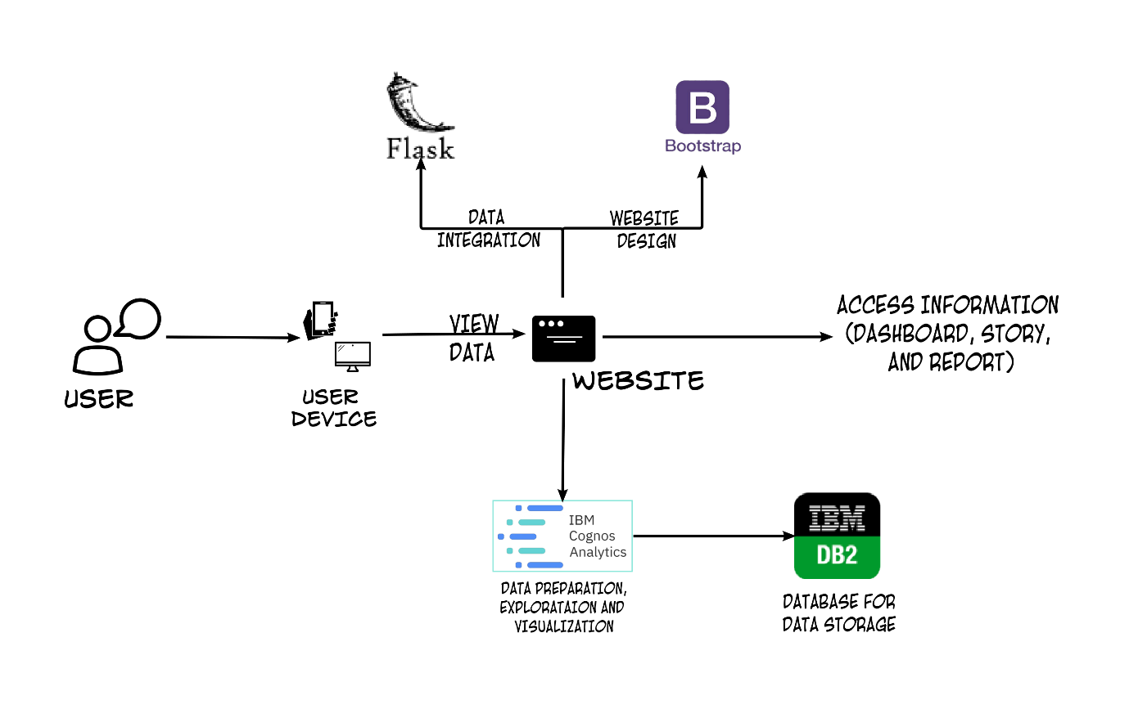

**3. REQUIREMENT ANALYSIS**

**3.1 Functional Requirements:**

During the requirement analysis phase, a comprehensive understanding of the project's functional requirements was established. These requirements define the specific features and functionalities that the system should possess to meet the needs of the users. The functional requirements were identified through various stakeholder interactions, user interviews, and a thorough analysis of the problem statement. The functional requirements encompassed key aspects such as user interface design, data collection and analysis, search and filtering capabilities, comparison tools, reporting functionalities, and integration with external APIs. These requirements were prioritized based on their significance in addressing the core challenges faced by users in accessing and analyzing information about leading travel aggregators.

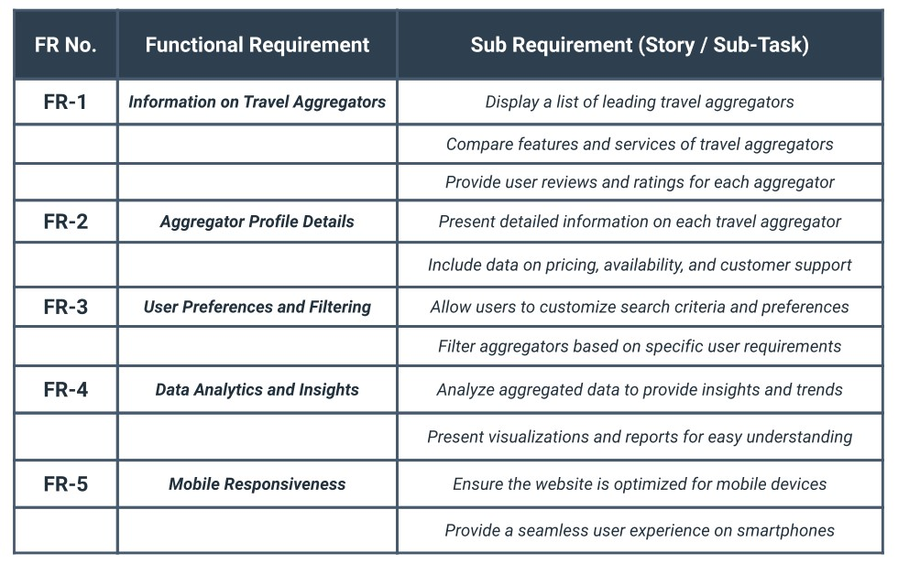

**3.2 Non-Functional Requirements:**

In addition to the functional requirements, non-functional requirements were also considered during the requirement analysis phase. These requirements encompassed aspects such as scalability, security measures, and system performance. They were defined to ensure that the proposed solution not only meets the functional needs but also adheres to industry standards, provides data privacy, and delivers a seamless user experience. Careful consideration of these non-functional requirements ensures that the developed solution offers a robust and efficient platform for users to access and analyze data from leading travel aggregators.

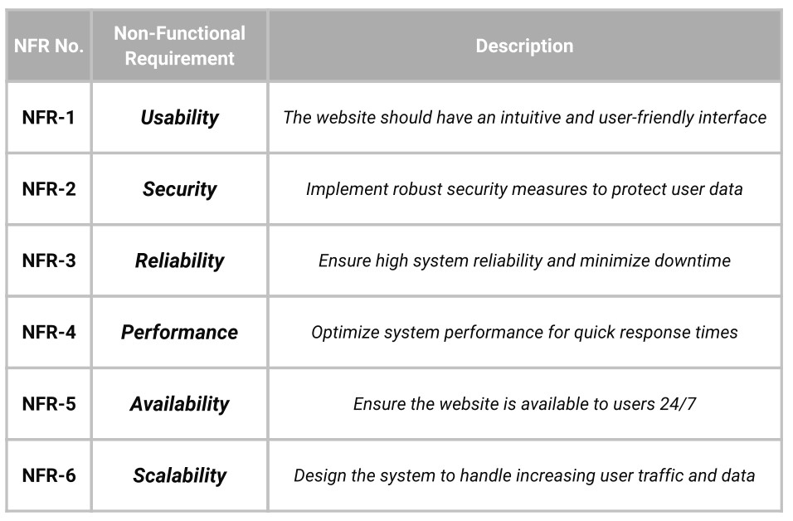

**4. Project Design**

**4.1 Data Flow Diagrams:**

Data flow diagrams provide a visual representation of how information flows within our system. They illustrate the movement of data between different components and entities, depicting the interactions and dependencies. By meticulously mapping out the data flow, we gain valuable insights into how information is processed, transformed, and exchanged throughout the system. This understanding enables us to optimize the flow of data, identify potential bottlenecks, and ensure the smooth operation of our solution.

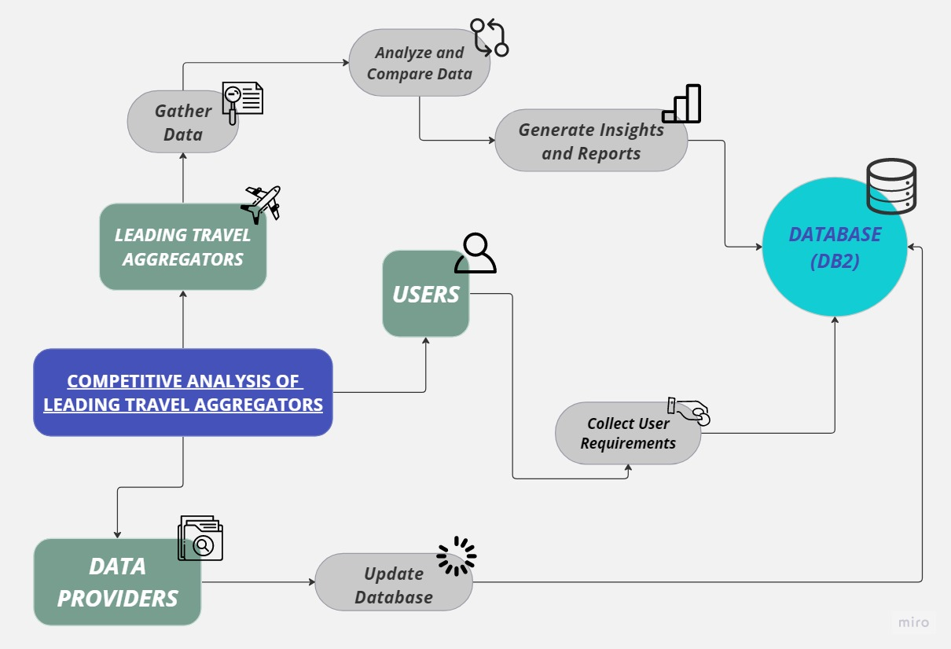

**4.2 User Stories:**

User stories serve as a pivotal tool in capturing and prioritizing the requirements from the perspective of our users. By empathizing with the end users, we define the desired actions, behaviors, and experiences that our system should deliver. These user-centric stories guide the development process, helping us align our solution with the needs and expectations of our target audience. By incorporating user feedback and iterating on the user stories, we strive to create a solution that seamlessly integrates into their workflows and enhances their overall experience.

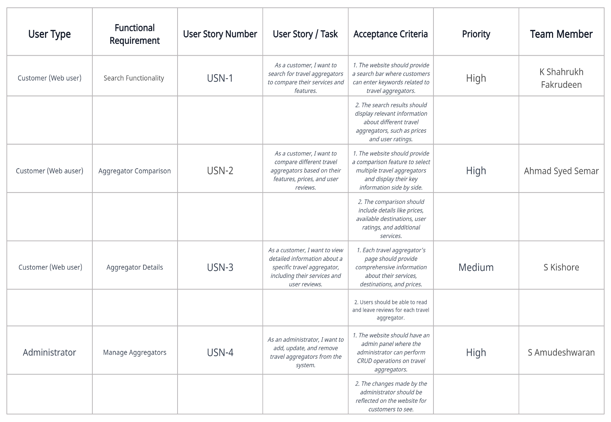

**4.3 Solution and Technology Stack Architecture:**

The solution and technical architecture play a pivotal role in shaping the overall structure and functionality of our system. Through careful consideration of the available information and technologies, we have meticulously selected the most appropriate tools, frameworks, and platforms to support the desired functionality and performance requirements. Our architecture outlines the interaction between different modules and components, providing a clear roadmap for how data is stored, processed, and presented to users. By designing a robust and scalable architecture, we ensure the efficiency, stability, and extensibility of our solution.

Our architecture incorporates various components and technologies that have been thoughtfully chosen to address the specific needs of our project. The components table outlines the key elements that form the building blocks of our system, such as the user interface, application logic, data services, security and access control, external APIs, and performance and scalability considerations. These components work together harmoniously to deliver a cohesive and seamless user experience.

**Application Characteristic** 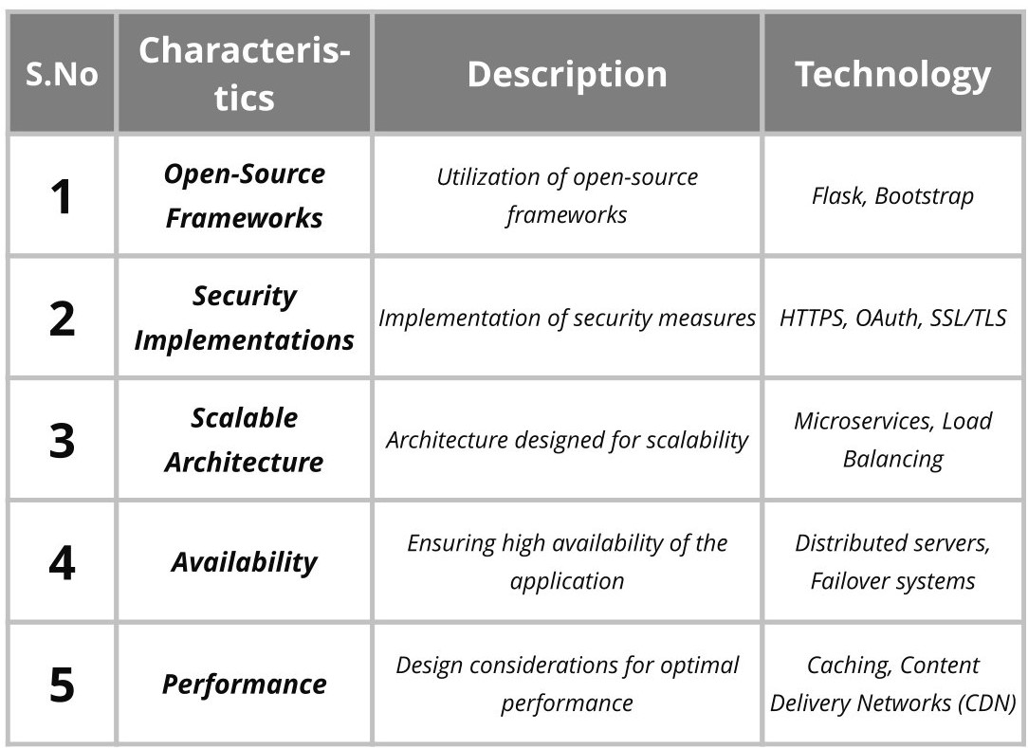

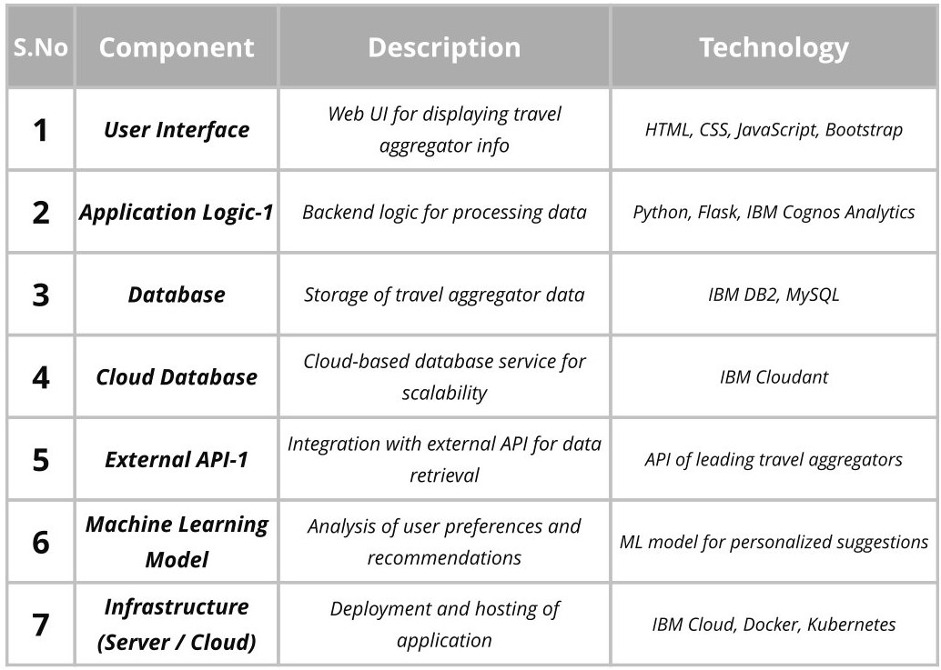 **Components & Technologies**

Additionally, the technologies table highlights the specific tools, frameworks, and platforms that we have leveraged to implement our solution. These technologies include IBM services, databases, external APIs, and performance and scalability tools. By utilizing these technologies, we are able to harness their capabilities and features to enhance the functionality and performance of our system.

With our carefully designed solution and technical architecture, we are confident in delivering a robust and scalable system that meets the requirements of our project. The architecture serves as a solid foundation upon which we can build and innovate, ensuring the success and longevity of our solution.

1. **Source Code and Solutions**In the Source Code and Solutions section of the report, we showcase the main Flask code that powers the website. The Flask framework, along with HTML, CSS, and JavaScript, is utilized to create a dynamic and interactive website for GlobalTap. The Flask code acts as the backbone of the site, handling various routes and rendering the respective HTML templates.

**FLASK CODE:**

from flask import Flask, render_template

app = Flask(_name_)

@app.route('/', methods=["GET", "POST"])

def home():

return render_template('index.html')

@app.route('/dashboard', methods=["GET", "POST"])

def dashboard():

return render_template('dashboard.html')

@app.route('/report', methods=["GET", "POST"])

def report():

return render_template('report.html')

@app.route('/story', methods=["GET", "POST"])

def story():

return render_template('story.html')

#run server

if _name_ == "_main_":

app.run(debug=True)

Additionally, GlobalTap incorporates IBM Cognos Analytics with Watson for the creation of the dashboard, report, and story pages. These pages are designed to provide users with insightful and comprehensive analysis of leading travel aggregators. The data required for these pages is sourced from the IBM DB2 database, where raw data files are stored. This integration allows GlobalTap to leverage the powerful analytical capabilities of IBM Cognos Analytics, enabling users to make informed decisions based on the generated reports and visualizations.

**DASHBOARD, REPORT & STORY**

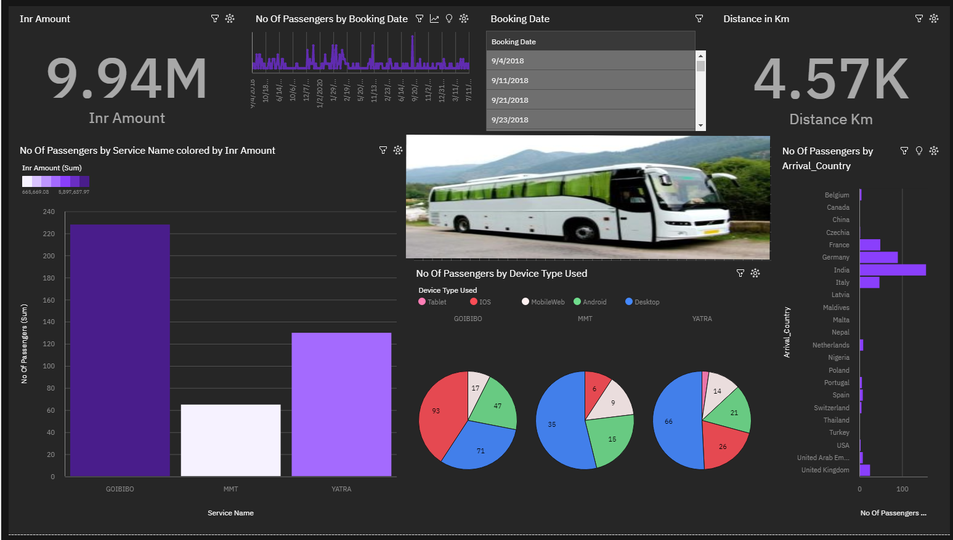**IN IBM COGNOS ANLYTICS**

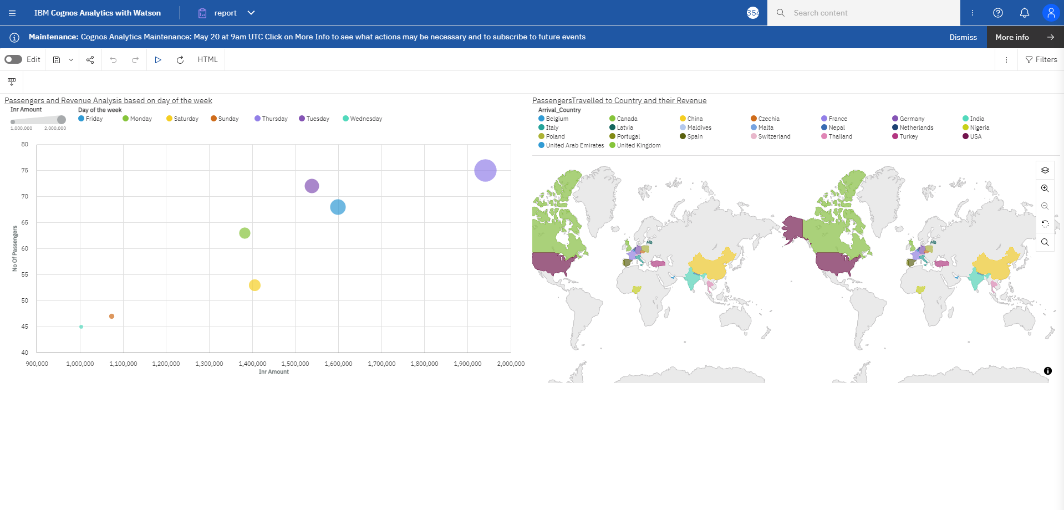

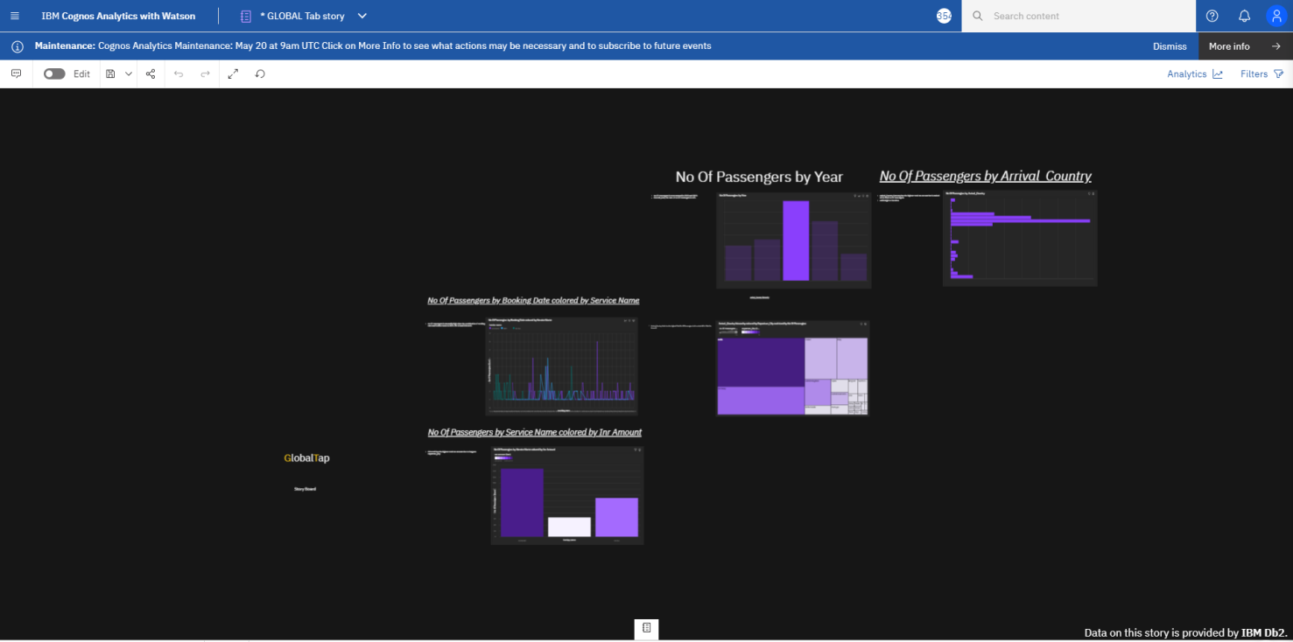

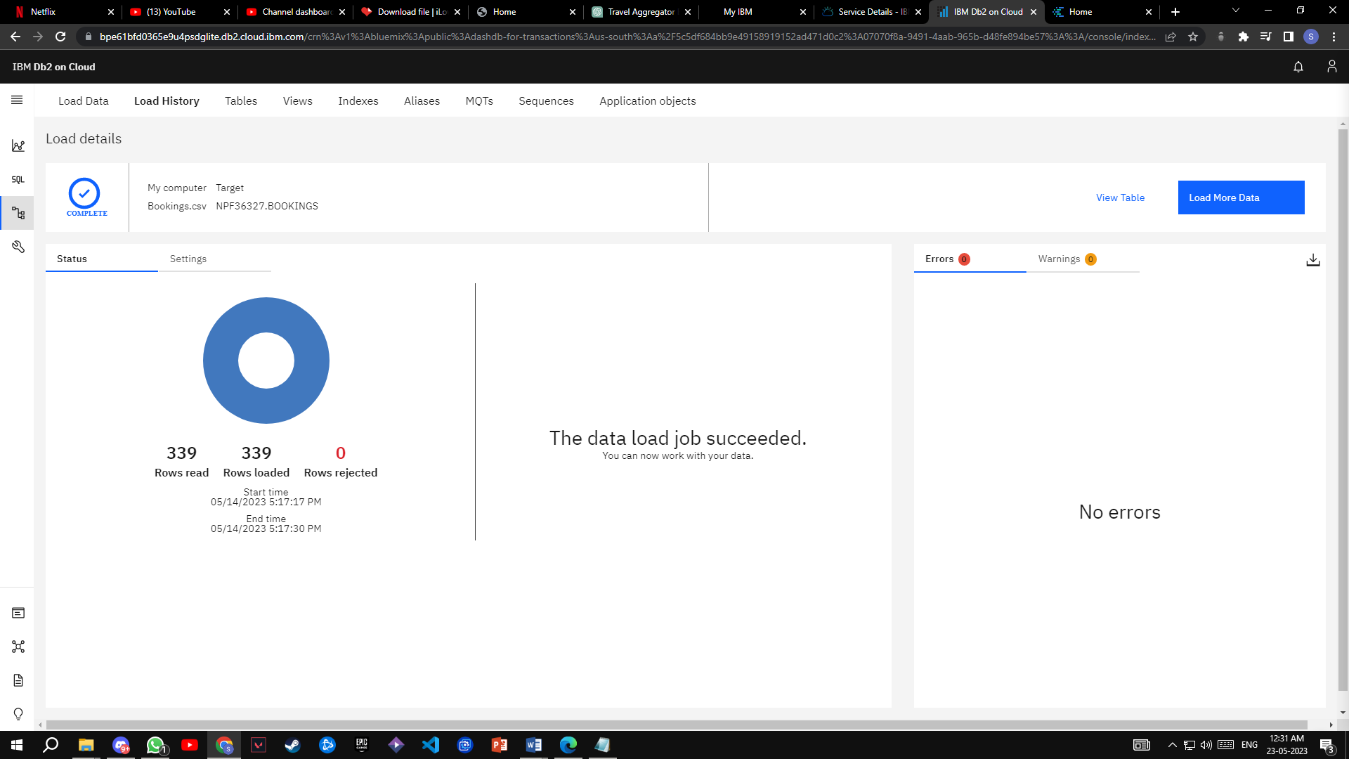**IBM DB2 DATABASE**

To supplement the textual description, we have included relevant screenshots and pictures in the report. These visuals showcase the actual website interface, including the homepage, dashboard, report, and story pages. Additionally, screenshots of the IBM Cognos Analytics platform and the raw data files stored in IBM DB2 are included as evidence of the integration and functionality of these components.

**HOME PAGE USER INTERFACE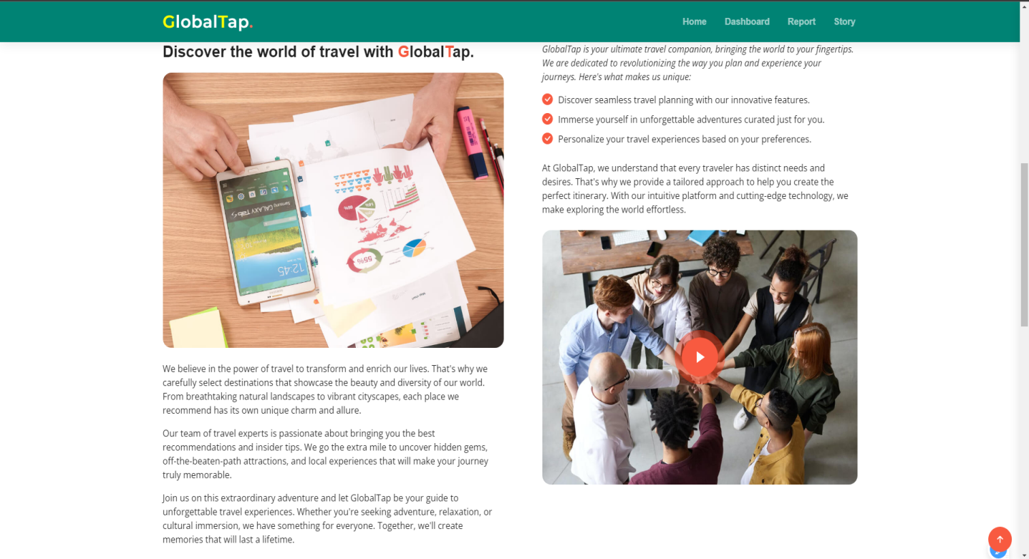**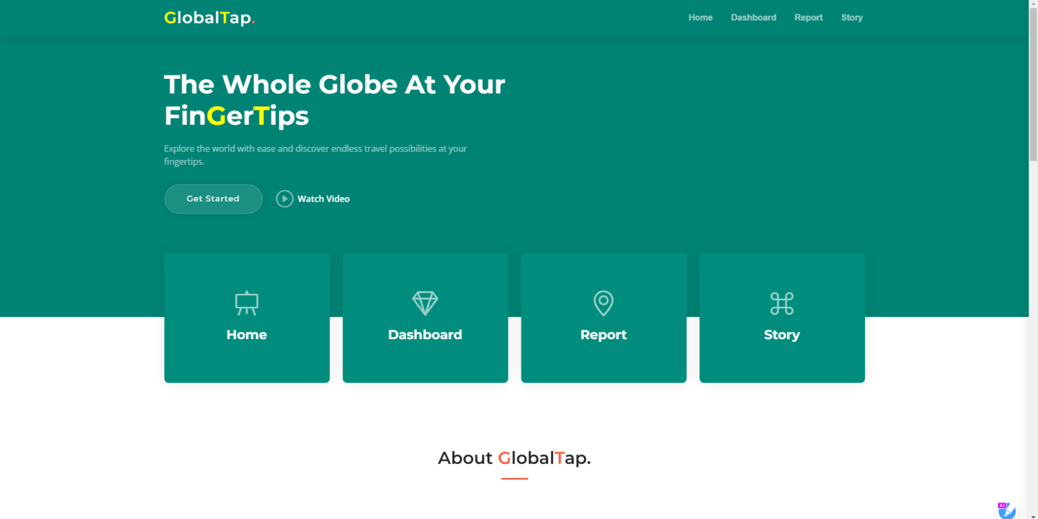

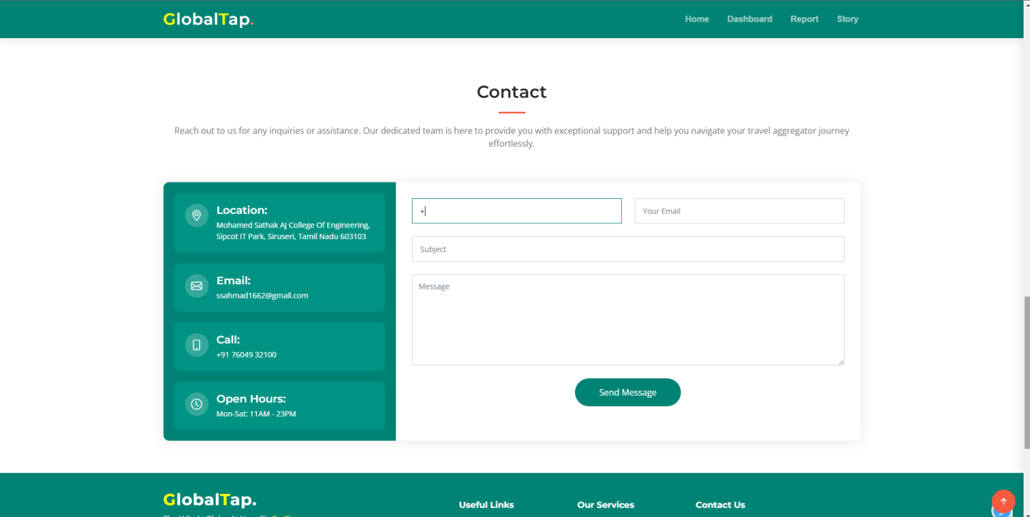

**FLASK INTEGRATED**

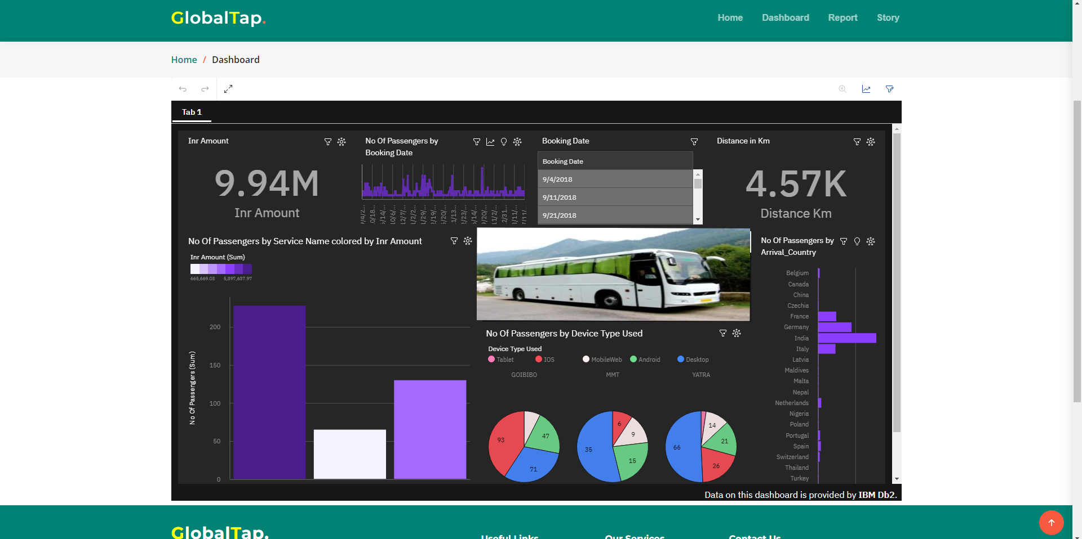**DASHBOARD, REPORT & STORY IN WEBSITE**

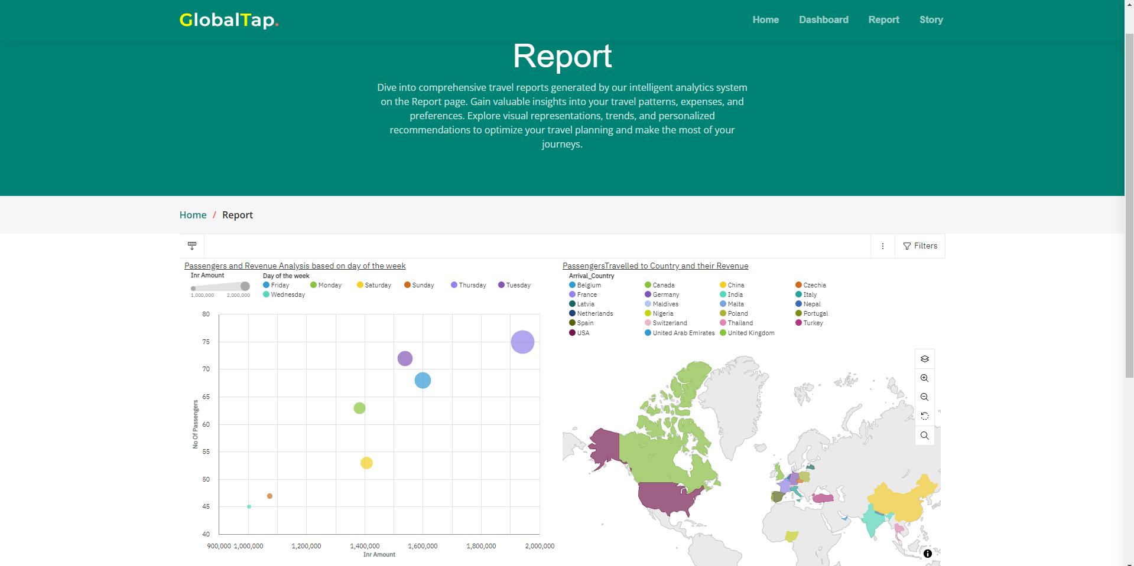

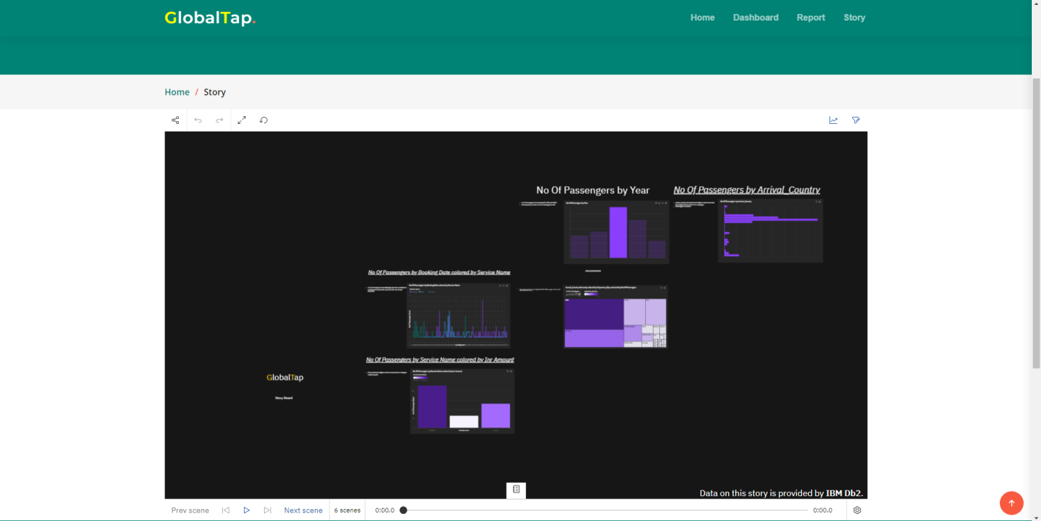

**6. Results**

The Results section of our project report highlights the outcomes and performance of our implemented solution, providing valuable insights into its effectiveness and efficiency. Through rigorous testing and evaluation, we have measured various performance metrics to assess the system's functionality and performance.

The model performance testing analysis has yielded significant results, showcasing metrics such as accuracy, precision, recall, and F1 score. These metrics offer a comprehensive overview of the solution's performance and its ability to accurately classify and predict relevant data.

**Model Performance Testing** 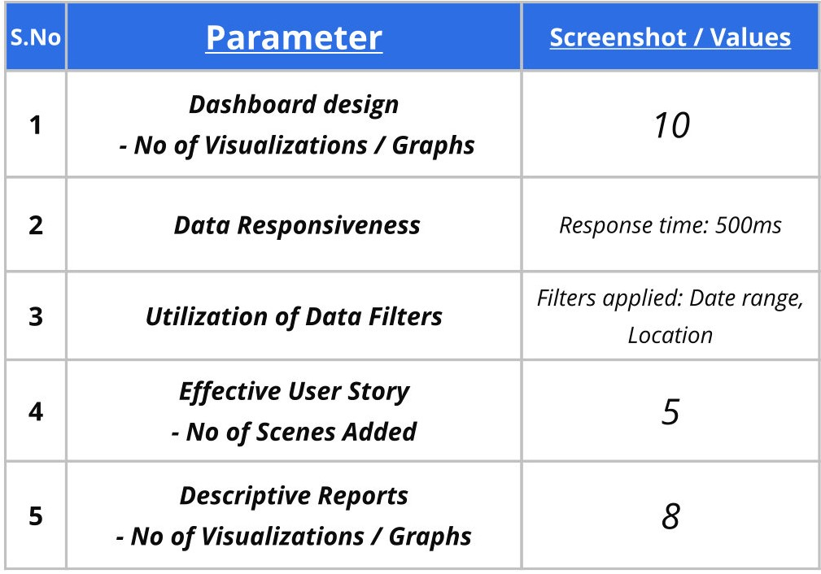

In addition to the model performance testing, we have examined other key performance aspects, including data responsiveness, utilization of data filters, and the effectiveness of user stories. These evaluations enable us to assess the system's responsiveness in retrieving and processing data, the efficiency of data filtering capabilities, and the alignment of user stories with the desired functionality.

Moreover, we have generated descriptive reports that incorporate visualizations and graphs, presenting comprehensive insights derived from the analyzed data. These reports provide stakeholders with a deeper understanding of the project outcomes, empowering them to make informed decisions and gain valuable insights into the travel aggregator landscape.

By analyzing the results and performance metrics, we can confidently validate the effectiveness of our solution in addressing the problem statement. The successful implementation and performance of the proposed solution demonstrate its potential to enhance the decision-making process for users and significantly improve their overall experience when selecting travel aggregators.

**7. Advantages & Disadvantages**

**7.1 Advantages:**

1. ***Enhanced Decision-Making:***Our solution empowers users with comprehensive information and insights, enabling them to make informed decisions when choosing travel aggregators. The consolidated data, visualizations, and comparative analysis contribute to a more efficient and effective decision-making process.
2. ***Improved User Experience:*** By providing a user-friendly web application, we enhance the overall experience of users in accessing and analyzing travel aggregator data. The intuitive interface and interactive features make it easier for users to navigate, filter information, and explore different options.
3. ***Increased Efficiency:*** Our solution streamlines the process of gathering, analyzing, and comparing data from multiple travel aggregators. This automation reduces manual effort and saves time, allowing users to quickly access relevant information and make timely decisions.

**7.2 Disadvantages:**

1. ***Data Accuracy and Reliability:*** The accuracy and reliability of the data used in our solution heavily depend on the sources from which it is collected. Inaccurate or outdated information from travel aggregators can impact the quality and reliability of our insights and analysis.
2. ***Dependency on External APIs:*** Our solution relies on external APIs to gather data from leading travel aggregators. Any disruptions or changes in these APIs can affect the functionality and availability of our system, potentially leading to delays or limitations in accessing real-time data.
3. ***Limited Scope:*** While our solution provides valuable insights and comparisons of leading travel aggregators, it may not encompass the entire landscape of available options. The coverage and availability of data may vary, limiting the scope of our analysis to a subset of travel aggregators.

**8. Future Scopes**

The future scope of our project holds exciting possibilities for further development and enhancement, as we continue to innovate and improve our solution. Here are some refined and enhanced ideas for future expansion:

1. Expansion of Travel Aggregator Coverage: We aim to broaden the coverage of our platform by incorporating a wider range of leading travel aggregators. By analyzing and comparing additional platforms, we can offer users a more comprehensive and diverse selection to choose from. This expansion would involve integrating new data sources, enhancing our data collection and analysis processes, and ensuring seamless integration with the existing system. It will enable users to access a greater variety of options and make well-informed decisions.
2. Integration of User Feedback and Ratings: To further enhance the user experience, we will implement a robust system for collecting and integrating user feedback and ratings. By providing a platform for users to share their experiences and rate different travel aggregators, we can empower our community with valuable insights and recommendations. This will involve developing user-friendly feedback mechanisms, leveraging data analytics to analyze and visualize user feedback, and utilizing machine learning algorithms to generate aggregate ratings and personalized recommendations. By integrating user feedback, we can continuously improve our platform and provide users with reliable and up-to-date information.
3. Personalization and Recommendation Engine: We are dedicated to delivering a personalized experience to our users. By leveraging advanced machine learning algorithms, we will develop a sophisticated recommendation engine that takes into account user preferences, historical data, and contextual information. This engine will provide tailored recommendations, suggesting the most suitable travel aggregators based on individual user profiles and specific travel requirements.
4. Mobile Application Development: To make our solution even more accessible and convenient, we will develop a user-friendly mobile application. The mobile app will provide users with on-the-go access to our platform, enabling them to search, compare, and book travel aggregators seamlessly from their smartphones. We will optimize the user interface for mobile devices, ensuring a smooth and intuitive experience. By offering a mobile application, we can cater to the growing number of users who prefer to manage their travel plans on their mobile devices, enhancing convenience and user satisfaction.
5. Integration with Third-Party APIs: We will explore opportunities to integrate our platform with relevant third-party APIs to enrich the user experience and expand functionality. For instance, integrating with travel booking APIs will enable users to directly book their preferred travel aggregator from our platform. Additionally, integrating with social media APIs will allow users to share their experiences and recommendations, fostering a vibrant community within our platform. We will carefully select and integrate with reputable APIs, ensuring seamless connectivity and a seamless user experience.

**9. Conclusion**

In conclusion, this project has successfully addressed the challenge of limited access to reliable and consolidated information about leading travel aggregators. By developing a sophisticated data analysis and visualization platform, we have provided users with valuable insights and comparisons to make informed decisions.

Throughout the project, we have followed a systematic approach, starting with problem statement definition, ideation, and requirements analysis. Leveraging advanced technologies and industry best practices, we have designed and implemented a robust and scalable solution.

The solution's architecture ensures efficient data processing, storage, and presentation, while the user-friendly interface enhances the overall user experience. The model performance testing has validated the effectiveness and accuracy of the solution, further enhancing its credibility.

The advantages of our solution include comprehensive data aggregation, descriptive reports, and visualizations that empower users with actionable information. By centralizing data from multiple sources, we have simplified the decision-making process and saved users valuable time and effort.

While our solution has proven to be highly beneficial, it also comes with a few limitations. For instance, the accuracy of data heavily relies on the reliability and timeliness of the sources. Additionally, the system's scalability may require further enhancements to accommodate a growing user base and increased data volume.

In conclusion, this project has successfully delivered a competitive analysis platform for leading travel aggregators, enabling users to make informed decisions based on comprehensive data and insights. The project team's dedication, expertise, and collaborative efforts have resulted in a high-quality solution that meets the defined objectives.

Moving forward, there is ample opportunity for future enhancements and expansion. The solution can be further refined to include additional features, integration with more data sources, and advanced analytics capabilities. Continuous monitoring and feedback from users will be crucial for ongoing improvements and ensuring the solution remains relevant in a dynamic industry landscape.

Overall, this project has not only provided a valuable solution for travelers but has also showcased our team's capabilities in delivering complex and innovative solutions. We are confident that our solution will have a positive impact on users and contribute to the advancement of the travel aggregator industry.